BIO ADSORBENT FOR ENVIRONMENTAL APPLICATIONS

**Project report**

*Submitted under the supervision of*

**Prof. Gopal Das**

*for the degree of*

**Bachelor of Technology**

in

Chemical Science and Technology

By

**DEEPAK KUMAR MANDAL**

(Roll No. 170122014)



DEPARTMENT OF CHEMISTRY

INDIAN INSTITUTE OF TECHNOLOGY, GUWAHATI

November 2020

|  |
| --- |
| **B**IO **A**DSORBENT **F**OR **E**NVIRONMENTAL **A**PPLICATIONS |

**Contents:**

1. A brief introduction to the "Bio Adsorbent for Environmental Applications" will be present in the article.
2. Background of the "Bio adsorbent for the adsorption of heavy metal ions and toxic dyes."

* Different Types of Bio adsorbent
* Advantages of Bio adsorbent in comparison of Chemical adsorbent

1. Recent Advances to promote Bio Adsorbent for Environmental Applications.

* Usage of Bio adsorbent for the adsorption of toxic heavy metal ions
* Usage of Bio adsorbent for the adsorption of toxic dyes molecule

1. Conclusion/Summary
2. References/Bibliography

**I**NTRODUCTION

Bio adsorption or biosorption refers to biological materials' ability to preferentially concentrate specific substance or molecular species such as heavy metals ion, dyes from the medium or solution by the way metabolically mediated or physical and chemical pathway of uptake. The materials or substances on the surface of which the biosorption occurs is known as bio adsorbent. The bio adsorption mechanism of metal ions by adsorbent is usually complex and involves one or combinations of different processes. [1]

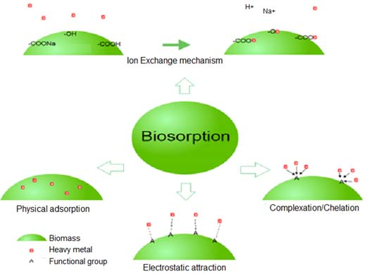

*Scheme 1: A graphical representation of the mechanism involved in bio adsorption of toxic heavy metal ions*

As we know, Heavy metals are toxic pollutants that commonly present in aqueous solutions or wastewater. Let's understand where these heavy metal ions come into our environment. So, there are the following source of introduction of metal ions which includes lead (Pb), arsenic (As), mercury (Hg), nickel (Ni), chromium (Cr), zinc (Zn), cadmium (Cd), and copper (Cu):-

1. Natural sources such as volcanic emissions, deep-sea vents, forest fires, etc.
2. Anthropogenic source such as mining activities, pesticides, petroleum refinery, smelting, metal-manufacturing plants, battery manufacturing, pigment, painting and coating industries, etc. [2]

Another common pollutant is Dyes, which typically come from textile industries. Heavy metals are also toxic, not bio-degradable; thus, they are dangerous for the health of humans and the environment.

**B**ACKGROUND **O**F **T**HE **F**IELD

**There are following two types of Bio adsorbent** [3]**:-**

1. Living organic materials
2. Non-living organic materials

*i.) Further, Living organic materials have been classified into four parts:-*

1. Bacterial bio adsorption:- The structure of bacteria is shown in scheme 1. The cell wall of Bacterium consists of various functional groups such as an amine (-NH2), hydroxyl (-OH), sulfate (-SO4H), carboxyl (-CO2H), phosphate(PO43-), which is responsible for binding with heavy metal ions and dyes.

The mechanisms responsible for bio adsorption are maybe one or the combination of complexation, electrostatic interaction, ion exchange, chelation, coordination, and microprecipitation. [4]

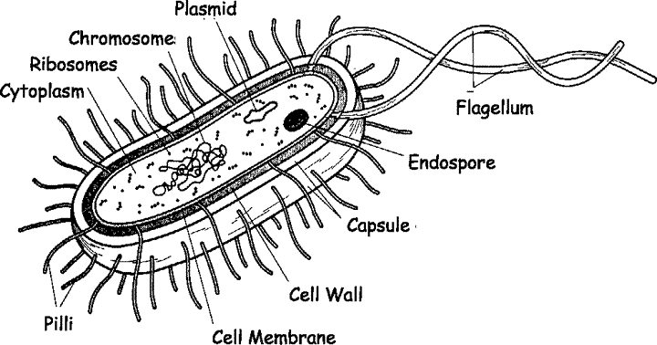

*Scheme 2: Structure of Bacterial Cell*

1. Bio adsorption by yeast:- The most common example of yeast is "Saccharomyces cerevisiae". The biomass of yeast consists of the element like Carbon (C), Oxygen (O), Sodium (Na), Magnesium (Mg), Phosphorus (P), Potassium (K). Here, Bio adsorption of metal ions takes place mainly by the ion exchange mechanism. [5]

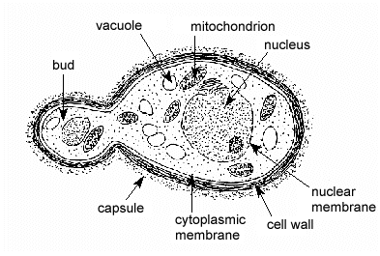

*Scheme 3: Structure of Yeast, Saccharomyces cerevisiae*

1. Bio adsorption by algae:- Algae is an aquatic plant that has no right stems and roots. The cell wall of algae consists of functional groups such as amino, hydroxyl, imidazole (C3H4N2), sulfate, phosphate, and amine. The mechanism of metal uptake in algae cells is the same as that of bacteria. [3]

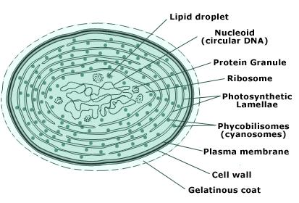

*Scheme 4: Structure of algae cell*

1. Bio adsorption by fungi:- The fungi are eukaryotic living organisms such as mushrooms, yeasts, etc. The mechanism involved in bio adsorption by fungi is either by bioaccumulation or metal uptake process by the fungi's cell wall that has a functional group like uronic acids, phosphate, nitrogen-containing ligand, carboxyl, proteins, chitin, chitosan.

|  |
| --- |
| *Scheme 5: Structure of fungi* |

*ii.) And Non-living organic materials are the wastes of food industries or agricultural* by-products such as cottonseed hulls, rice husk, corn cobs, activated charcoal, or fruit peels. It contains cellulosic materials in their cell wall with carboxylic (-COOH) or phenolic (-OH) as a functional group.

The binding of heavy metal ions with the functional groups by the cation exchange process results in bio adsorption, and hence, removing heavy metal ions takes place from the medium.

|  |  |  |
| --- | --- | --- |
| Rice husk | Fruit peels | Cotton seeds hulls |
| Soya bean hulls | Corn cobs |  |

*Figure 2: The pictorial representation of the waste of the agricultural or food industry may be used as bio adsorbent.*

**Advantage of Bio Adsorbent in Comparison of Chemical Adsorbent:** [3, 6]

* Bio adsorbent is relatively inexpensive in comparison to the chemical adsorbent.
* Bio adsorbent has features like high selectivity and efficiency or outstanding performance.
* As a Bio adsorbent, we use either living or non-living materials, which is basically biological sludge for adsorption purposes, and it is eco-friendly. Hence, we are minimizing the use of chemical substances, and that acts as an edge of Bio adsorption over Chemical adsorption.
* Regeneration or renewal of bio adsorbent.
* Production to no extent of toxic substances. Therefore, bio adsorbent involves much greener approach to adsorption of toxic heavy metal ions and toxic dye molecules in comparison to the chemical adsorbent.

Few basic facts are involved in the adsorption process, where the activated carbon-based bio adsorbent is used for the adsorption of toxic heavy metal ions.

Activated carbon has been prepared from the Pistachio shells, and one can get these shells from the pistachio trees.

Now we will see some basic terms used throughout the adsorption process of cellulose-keratin-based bio adsorbent, which is used for adsorption of toxic dyes molecules.

Dyes:- It is used to color the substrates, to which they have an affinity. Dye has a complex structure and thus, it is stable and not biodegradable in the environment [8]. It includes a variety of functional group such as azo (-N=N-), carbonyl (=C=O), nitro (-NO or =NO-OH), carbon (=C=C=), nitroso (-NO or N-OH), sulfur (=C=S) etc., which are different color properties.

There are following few examples of commercial dyes and their chemical structures:-

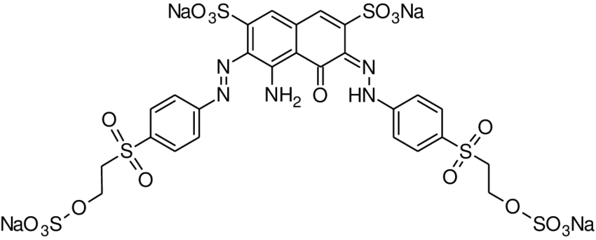

RB5: Reactive Black 5 (C26H21N5Na4O19S6)

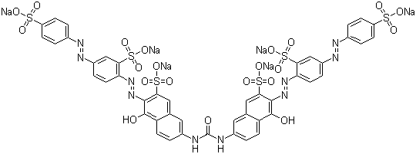

DR80: Direct Red 80 (C45H26N10Na6O21S6)

From figure 1, we can say that a typical hen feather contains functional groups such as -COOH, -OH, -(NH)-(CO)-, and that can play an essential role in various interactions between adsorbent and dye molecule that leads them to be separated.

|  |  |
| --- | --- |
| Chemical Structure of feather | Chemical Structure of Cotton |

*Figure 1: Chemical Structures of a typical feather and cotton*

Keratin could be from butchery wastes like feathers, low-quality wood, animal hairs, or textile industries' waste fabrics. It includes functional groups such as amino (-NH2), carboxyl (-COOH) groups on its molecule, which play a crucial role in the adsorption of dye molecules because it acts as active adsorption sites for removal of toxic dyes. [8]

**R**ECENT **A**DVANCES **T**O **P**ROMOTE **B**IO **A**DSORBENT

Let's take an example of bio adsorbent for the adsorption of toxic heavy metal ions.

**A modified bio adsorbent has been prepared by the loading of Fe3O4 nano-particles and immobilization of 1,4-butane sultone (-SO3H) on the surface of activated carbon.** [7]

There are following two steps involved in the synthesis of modified activated carbon-based bio adsorbent (as shown in scheme 6):-

1. The Activated Carbon (AC) is produced from the agricultural wastes. It is a natural resource of carbon. By Supporting Fe3O4 nano particles onto activated carbon, we get the modified resulting surface with a large number of active sites that can increase the chemical adsorption or chemisorption. Hence, modified activated carbon chemistry has been developed, which has the presence of a functional group-containing oxygen atom that plays essential role for the removal of heavy metals. Because these groups can form complex with heavy metal ions. Here, the reaction has to be done in the ultrasonic probe.
2. Fe3O4 nano-particle activated carbon can be separated by using an external magnet. Further, this is subjected to 1, 4 – butane sultone via ring-opening reaction, followed by sonication under mild condition, to enhance the acidic functional groups on the Fe3O4 nano-particle activated carbon. That will result in **nano-composite,** which is termed as **Fe3O4 NPs@AC@C4H8SO3H composites**. Here 1, 4 - butane sultone is a reagent and potent chelating or complexing agent which helps in achieving the desired objective of separation of heavy metals, because it includes sulfur and oxygen atoms that could be strongly combined with heavy metal ions and cause them to separate.

|  |
| --- |
| *Scheme 1.1: The synthesis processes of nano-composites and their structures.* |

***The mechanism for adsorption of heavy metal ions:***

According to the given mechanism (as shown just above in Scheme 7), the heavy metal ions forms involved with the sulfonic acid (-SO3H), hydroxyl (-OH), and carboxyl (-CO2H) group presents on the surface of Fe3O4 NPs@AC@C4H8SO3H composites. This is the primary factor that causes the separation or adsorption of the heavy metals from aq. Solutions.

|  |
| --- |
| *Scheme 7: Mechanism for adsorption of toxic metal ions on the surface of bio adsorbent.* |

The adsorption of toxic heavy metal ions on this nano-composite bio-adsorbent depends upon various factor such as:-

* The pH of the solution
* Temperature
* Dosage or amount of adsorbent
* The initial concentration of the metal ions like As(III), Cd(II), Pb(II).
* Time of contact with adsorbent in the aqueous solution.

From figure 3 as shown below, which is a graph of "pH Vs amount of metal ion adsorbed onto the adsorbent," We can analyze that on increasing the value of pH, the efficiency of adsorption of the heavy metal ions onto nano-composite has increased.

|  |
| --- |
| *Fig. 3: pH Vs adsorption capacity(mg g-1) graph* |

The reason behind is, when we increase the value of pH, deprotonation of the sulfonic acid (-SO3H), hydroxyl (-OH), and carboxyl (-CO2H) groups on the surface of the adsorbent takes place, which will have resulted in electrostatic interaction enhancement between the heavy metal ions and active sites of the nano-composite. The ***Recyclization process*** could be performed by just desorbing the metal ions from the adsorbent. The nano-composite biosorbent contained heavy metal ions is stirred in HCL solutions, followed by neutralization with sodium hydroxide (dil) solution. And then, it is recovered by using an external magnet. Further, it is subjected to the adsorption processes to determine its reusability.

***Usage:*** This modified bio adsorbent can be used for the adsorption of heavy metal ions such as Lead: Pb(II), Cadmium: Cd(II), and Arsenic: As(III) from aqueous solutions at an industrial scale.

Now, Let's take an example of bio adsorbent for the adsorption of toxic dye molecules.

**Cellulose nano crystal – reinforced keratin bio adsorbent for adsorption of dye molecules from aqueous solution.** [8]

There are the following steps involved in the preparation of cellulose-keratin based bio adsorbent (as shown below in Scheme 8):-

* At first, Keratin solution is prepared from feathers by immersing into urea (CH4N2O) solution with cysteine (HO2CCHCH2SH) followed by removal of undissolved feathers. This process is termed as Extraction.
* We get Cellulose nano-crystal (CNC) by the hydrolysis of cotton fabric with sulfuric acid (H2SO4).
* CNC is added into keratin solution by using the ultrasonication process, followed by the addition of a crosslinking agent. Here, Glutaraldehyde (C5H8O2) is acts as a crosslinking agent.
* Cellulose nano crystal reinforced keratin adsorbent is fabricated by the freeze-dried process. This process enhances the crosslinking reaction. Thus, we get the water stable bio adsorbent.

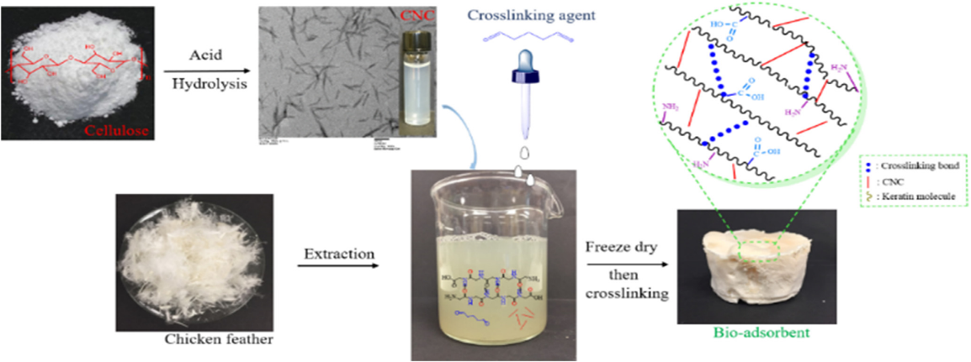

*Scheme 8: Synthesis of cellulose-keratin based bio adsorbent and their structure.*

***The mechanism for adsorption of toxic dyes molecule:***

From the mechanism as shown in Scheme 9, we can analyse that the separation of dye molecules from aqueous solution takes place due to the various interaction between the dye molecule and the functional groups like amino (-NH2), hydroxyl (-OH), and carboxyl (-COOH) group presents in the cellulose nanocrystal-reinforced keratin bio adsorbent:-

1. Formation of hydrogen bonds
2. Van der waals forces of interaction
3. The electrostatic force of interaction

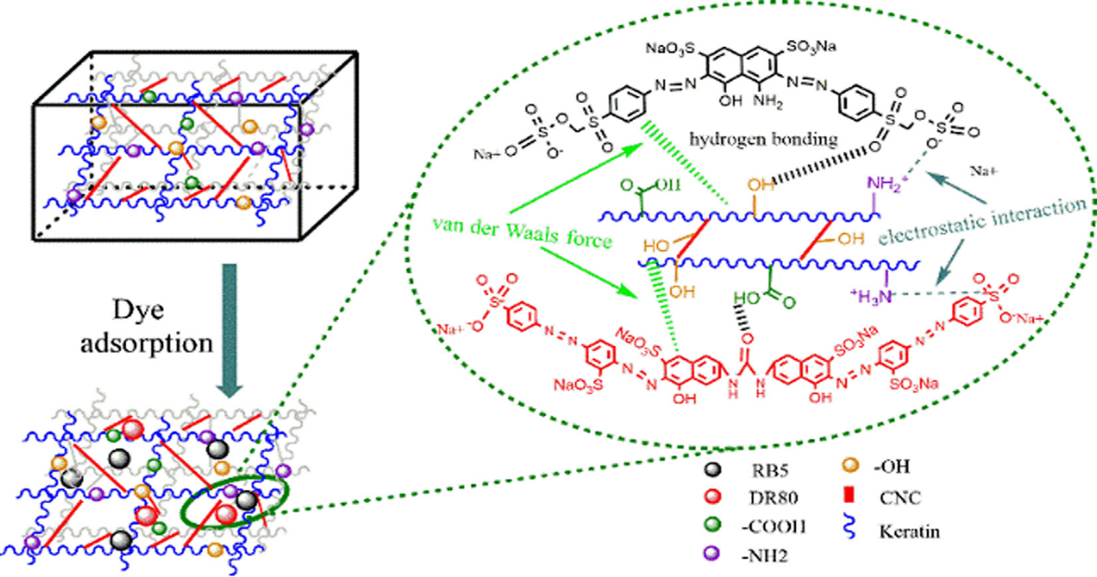

*Scheme 9: Mechanism for adsorption of dyes molecule in the cellulose-keratin based bio adsorbent.*

The mechanical property of adsorbent plays an essential role in recyclization or regeneration. We can increase the mechanical strength of bio adsorbent by reinforcing the cellulose nano crystal in the keratin sponge matrix. So, basically, it results in homogeneous dispersion of CNC nanoparticles with a huge number of point-to-point connections (which has been shown in the diagram with red line). Thus, improvement in the performance of the bio adsorbent. Hence, we can say that Cellulose Nano-Crystal acts as a nano-filler to provide dimensional stability and structural integrity to the bio adsorbent.

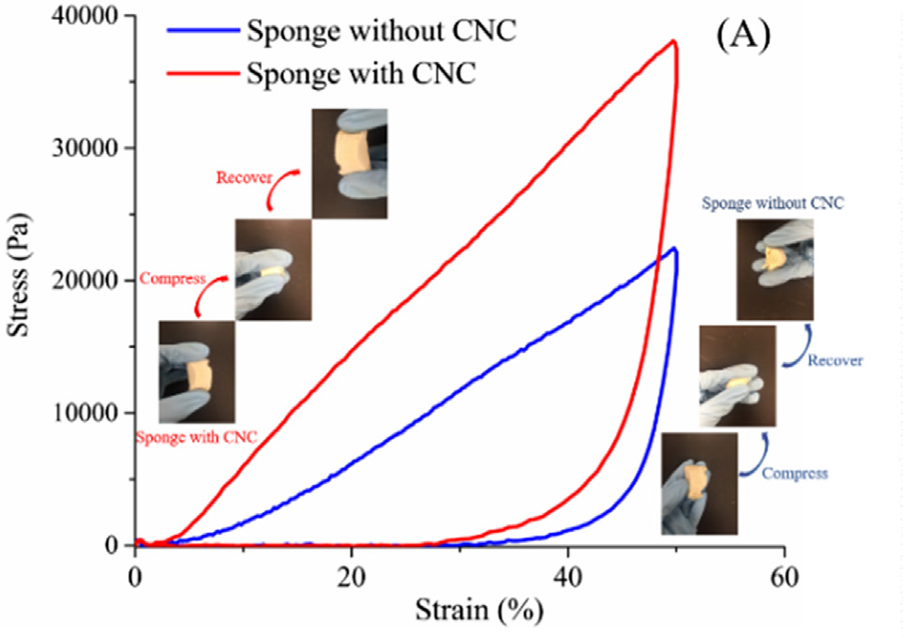

*Figure 4: Strain Vs Stress Curve, which shows structural shrinkage in two cases.*

This fabricated bio adsorbent has large specific surface areas, enhanced mechanical property with high porosity, which shows excellent performance for adsorption of dye molecules. The **recyclization** of cellulose-keratin-based bio adsorbent is executed by immersing the dyes containing adsorbent into sodium hydroxide solution with a compress's firmly press. Then the adsorbent is drawn out from the NaOH solution. Further, it is used again for adsorption of toxic dyes molecules from an aqueous solution. In this way, the regeneration of adsorbent leads to the high efficiencies of desorption after adsorption of dyes molecules and thus provides good reusability.

***Usage:*** This bio adsorbent is used for adsorption of dyes such as Reactive Black 5 (RB5), and Direct Red 80 (DR80) from aqueous solution or wastewater.

**C**ONCLUSION

The Best part here is - Apart from having a high adsorption capacity, this bio adsorbent exhibits advantages such as green synthesis, recyclization, low-cost, and, more importantly, easy separation with the technically feasible method. These bio adsorbents could be a suitable option for the adsorption of toxic heavy metal ions and toxic dyes. In this way, we could also put value added to the waste biomass. That's what makes it sustainable, renewable, and environmentally friendly alternative adsorbent for environmental applications.